
PB1/FMAK/1223/A 27-NOV-2023
PRE BOARD EXAMINATION- I (2023 -24 )
ANSWER KEY
Subject: FMM  Grade: 12 | Max. Marks: 60  Time: 3 hrs
Name: |  | Section: | Roll No:
SECTION A: OBJECTIVE TYPE QUESTIONS
Q 1 | Answer any 4 out of the given 6 questions on Employability Skills (1 x 4 = 4 marks)
i) | b. Perspectives | 1
ii) | b. Answer the phone and speak with her for as long as she wants. | 1
iii) | a. Intrinsic Motivation | 1
iv) | d.Formula | 1
v) | a. French word | 1
vi) | b. Food chain | 1
Q. 2 | Answer any 5 out of the given 7 questions (1 x 5 = 5 marks)
i) | c. clearing member | 1
ii) | b.The suspended trading members continue to be accountable to their creditors. | 1
iii) | Extend the term IEPF? | 1
iv) | What is snap quote? | 1
v) | a. National Exchange for Automated Trading | 1
vi) | c. Strict Price/time priority | 1
vii) | a. IOC/DAY/STOP LOSS orders | 1
Q. 3 | Answer any 6 out of the given 7 questions (1 x 6 = 6 marks)
i) | a. Yes, all Nifty50 stocks can set up or by default on market watch screen. | 1
ii) | a. S- Auction is in Solicitor Period | 1
iii) | b. Open Combo Box | 1
iv) | a. Securities Pay out | 1
v) | d. Replacement cost margin | 1
vi) | Short delivery happens when the seller (on the other side of your buy trade) fails to deliver the shares to the exchange to be credited to your demat account. | 1
vii) | - All of the above | 1
Q.4 | Answer any 5 out of the given 6 questions (1 x 5 = 5 marks)
i) | SURCON: Surveillance and Control (SURCON) is that period after market close during which, the users have inquiry access only. | 1
ii) | Selling or buying in securities on the basis of price sensitive unlisted information of a listed corporate , if listed could lead to fall or rise in prices of the shares. | 1
iii) | a.Debt-equity ratio, Interest coverge ratio, Debt-Assets Ratio | 1
iv) | To measure how efficiently all types of assets are employed. | 1
v) | d.EPS does not measures the profit available to the equity shareholders per share | 1
vi) | The relationship between value of a rupee today and value of rupee in future known as Time value of money | 1
Q.5 | Answer any 5 out of the given 6 questions (1 x 5 = 5 marks)
i) | c.Forward contracts | 1
ii) | c. Arbitrageurs | 1
iii) | d.All of the above | 1
iv) | Impact cost represents the cost of executing a transaction in a given stock, for a specific predefined order size, at any given point of time | 1
v) | A swap is an agreement between two parties to exchange sequences of cash flows for a set period of time | 1
vi | An option can be exercised at the expiry of the contract period. | 1
Q.6 | Answer any 5 out of the given 6 questions (1 x 5 = 5 marks)
i) | a. Put option | 1
ii) | a.Future contract | 1
iii) | a.Equity | 1
iv) | c.Basis | 1
v) | The price specified in the option contract | 1
vi | Measures the storage cost plus the interest that is paid to finance the asset less the income earned. | 1
 | SECTION B: SUBJECTIVE TYPE QUESTIONS
 | Answer any 3 out of the given 5 questions in 20 – 30 words each (2 x 3 = 6 marks)
Q.7 | Being aggressive is a better way to communicate. It involves  - expressing your thoughts without hurting others or yourself,  - respecting others,  - expressing yourself and your goals in a clear and concise manner,  - being receptive to other people’s opinions, and  - finding a balance between your needs and the needs of others | 2
Q.8 | Many contemporary personality psychologists believe that there are five basic dimensions of personality, often referred to as the "Big 5" personality traits. These five primary personality traits are extraversion (also often spelled extroversion), agreeableness, openness, conscientiousness, and neuroticism | 2
Q. 9 | Title Bar, Menu Bar , Standard Bar , Formatting Bar | 2
Q. 10 | In their daily operations, entrepreneurs handle a wide range of problems.  a. Creativity – An entrepreneur must believe in their ability to come up with new ideas to solve a problem.  b. Innovation – Innovation means thinking up new ideas and coming up with ways to make them work in real life. The difference between creativity and innovation is that, whereas creativity is simply coming up with an idea, innovation means coming up with an idea and making that idea a reality.  c. Critical Thinking – An entrepreneur always thinks differently when he/she is faced with a problem. Entrepreneurs never worry about the problem he/she always try to find out the solution. | 2
Q. 11 | A green economy is one which promotes development while making sure that the environment is protected. The term “Green Economy” was established in 1989 by a group of top environmental economists in a report called “Blueprint for a Green Economy” for the Government of the United Kingdom. | 2
 | Answer any 3 out of the given 5 questions in 20 – 30 words each (2 x 3 = 6 marks)
Q. 12 | 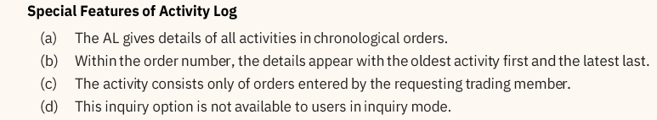 | 2
Q. 13 | 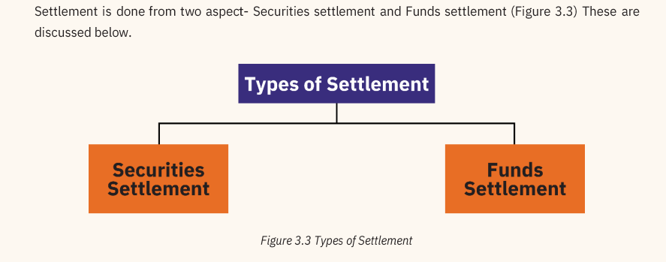 | 2
Q. 14 | 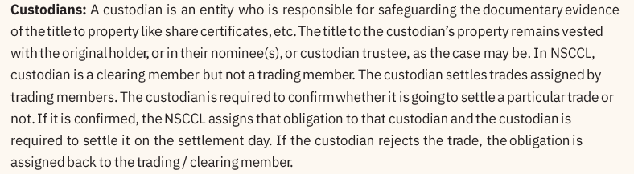 | 2
Q. 15 | - Earnings per share (EPS) is a company's net profit divided by the number of common shares it has outstanding.  - EPS indicates how much money a company makes for each share of its stock and is a widely used metric for estimating corporate value.  - A higher EPS indicates greater value because investors will pay more for a company's shares if they think the company has higher profits relative to its share price. | 2
Q. 16 | 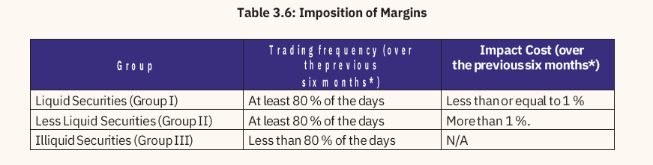 | 2
 | Answer any 2 out of the given 3 questions in 30– 50 words each (3 x 2 = 6 marks
Q 17 | 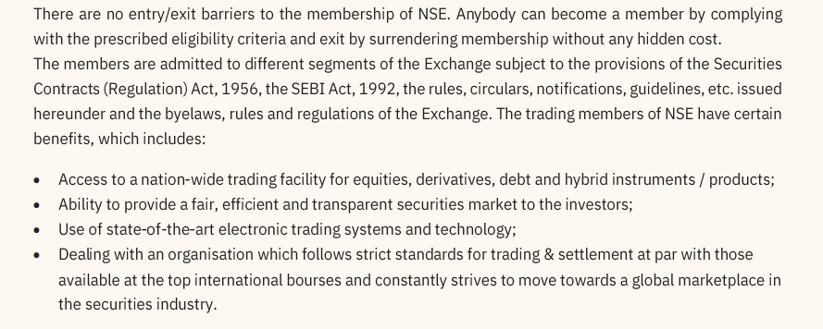 | 3
Q 18 | 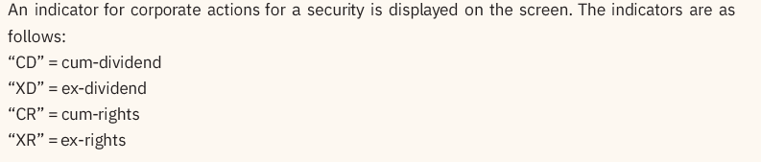  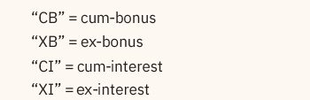 | 3
Q 19 | 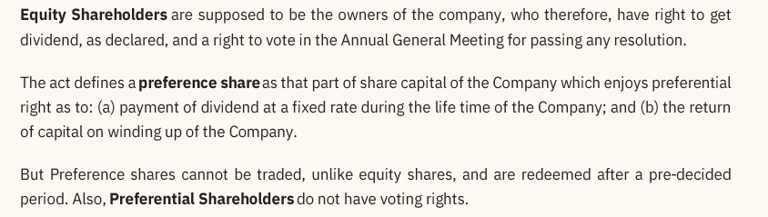 | 3
 | Answer any 3 out of the given 5 questions in 50– 80 words each (4 x 3 = 12 marks)
Q. 20 | 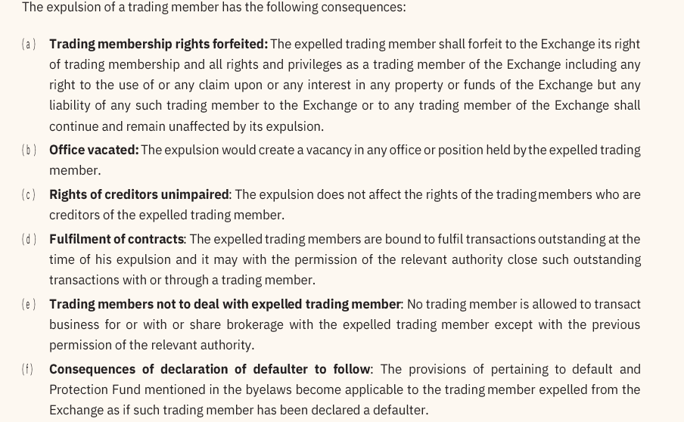 | 4
Q. 21 | 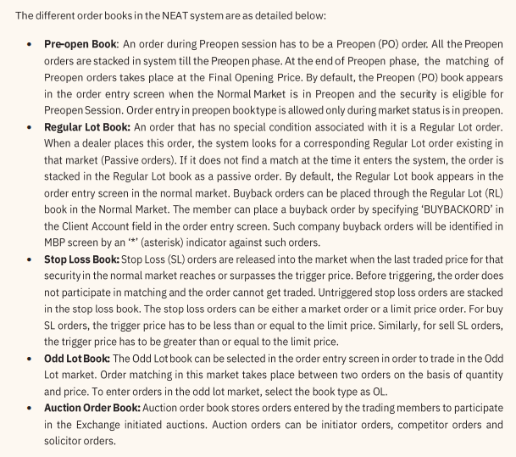 | 4
Q. 22 | 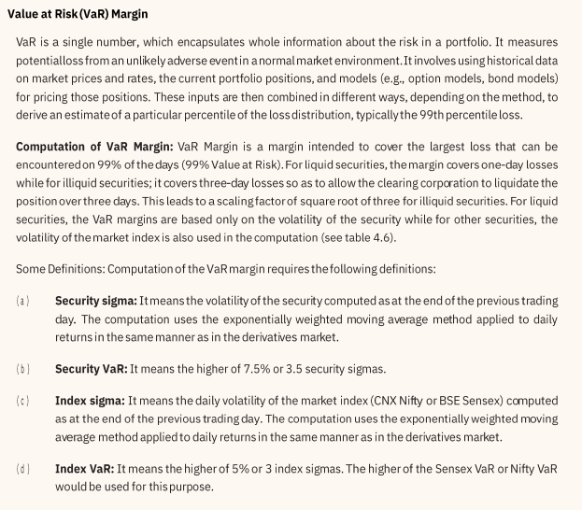 | 4
Q. 23 | 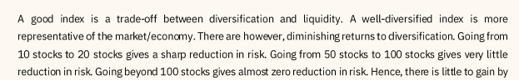  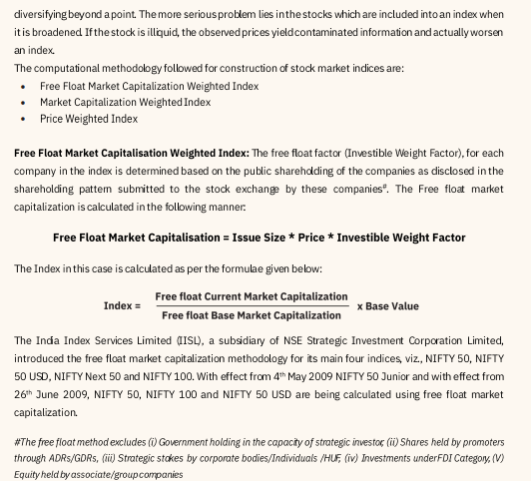  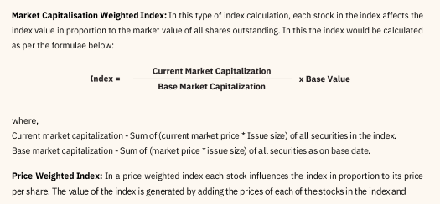 | 4
Q. 24 | 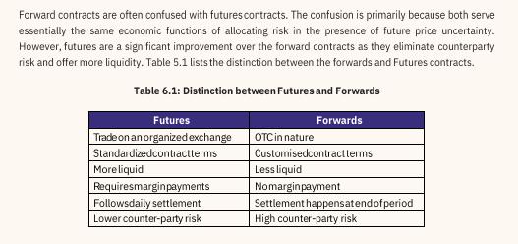 | 4
***

